Link to paper:

<http://repository.cmu.edu/cgi/viewcontent.cgi?article=1539&context=compsci&sei-redir=1&referer=http%3A%2F%2Fscholar.google.com%2Fscholar%3Fhl%3Den%26q%3D%25E2%2580%259CJ.-Y.%2BPan%252C%2BH.-J.%2BYang%252C%2BC.%2BFaloutsos%252C%2Band%2BP.%2BDuygulu.%2BAutom>

Formula used :

Equation 1 for Task 3b

Equation 2 for Task 3c

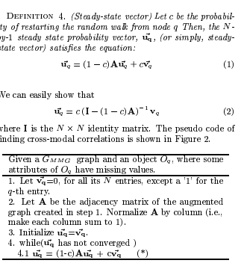

References:

Pan, Jia-Yu, et al. "Automatic multimedia cross-modal correlation discovery."*Proceedings of the tenth ACM SIGKDD international conference on Knowledge discovery and data mining*. ACM, 2004.